**PARTITIONS** : A MECHANISM TO DIVIDE THE TABLE DATA INTO MULTIPLE PARTS.

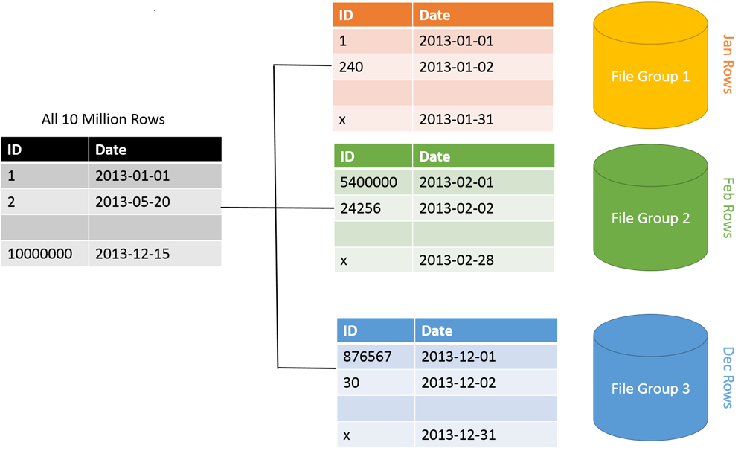

**STEPS TO IMEPLEMENT PARTITIONS**:

STEP 1: DEFINE PARTITION **FUNCTION** - TO SPECIFY THE CONDITION FOR DATA SPLIT

STEP 2: DEFINE PARTITION **SCHEME** - TO SPECIFY THE LOCATIONS FOR DATA SPLIT

STEP 3: PARTITION THE TABLE

STEP 4: APPLY COMPRESSIONS ON OLD (COLD) INACTIVE PART(S) OF THE TABLE [DWH]

**COMPRESSION** : A MECHANISM TO IDENTIFY UNIQUE VALUES OF A COLUMN AND STORE THEM ONLY ONCE. EX: IF MULTPLE CUSTOMERS HAVE SAME GENDER VALUE THEN STORE THE GENDER VALUE ONLY ONCE AND USE IT AS A REFERENCE FOR ALL REQUIRED CUSTOMERS. THIS SAVES SPACE.

ADVANTAGE OF COMPRESSION : LESS STORAGE SPACE. HENCE FASTER SEARCH.

DISADVANTAGE OF COMPRESSION: ANY UPDATES TO TABLE NEED RE-COMPRESS THE DATA.

-- IN REAL-TIME, WE USE COMPRESSION FOR DWH DATABASES (REASON: THEY STORE COLD DATA).

**TYPES OF COMPRESSION:**

** 1. **ROW COMPRESSION** : APPLICABLE FOR MULTIPLE COLUMNS WITH SIMILAR DATA

EXAMPLE : GENDER & MARITAL STATUS COLUMNS HAVE SAME VALUE "M". UNIQUE COLUMN VALUES ARE STORED

2. **PAGE COMPRESSION** : APPLICABLE FOR MULTIPLE ROWS WITH SIMILAR DATA

EXAMPLE: SAME PRODUCT SOLD TO SAME CUSTOMER AT THE SAME TIME.

HOW TO IMPLEMENT COMPRESSIONS?

ALTER TABLE SALES_DATA REBUILDPARTITION = 1 WITH ( DATA_COMPRESSION = ROW)

ALTER TABLE SALES_DATA REBUILD PARTITION = 1 WITH ( DATA_COMPRESSION = PAGE)

ALTER TABLE SALES_DATA REBUILD PARTITION = 1 WITH ( DATA_COMPRESSION = NONE)

-- TO COMPRESS ENTIRE TABLE :

ALTER TABLE SALES_DATA REBUILD WITH ( DATA_COMPRESSION = ROW)